

T.C.
GAZİANTEP UNIVERSITY
TEXTILE ENGINEERING

PROJECT TITLE

TE 499 GRADUATION DESIGN PROJECT

Student NAME SURNAME
Student Number

SUPERVISIOR
TITLE NAME SURNAME

2024 - 2025
FALL SEMESTER
PREFACE
I would like to thank my valuable supervisor ……………….
I would like to thank the faculty members of Gaziantep University, Faculty of Engineering, Department of Textile Engineering, and everyone who contributed for their support and interest in my education process.
I am grateful to my family, ………………………………….

CONTENT

1. INTRODUCTION ………………….……………………..…………………....…… 3
2. LITERATURE SURVEY ……….………………………………………...…….…... 4
3.MATERIALS AND METHOD ………………………………………….…..……… 5
3.1 Materials …………………………………………..…………………………………. 5
3.2 Experimental Set up ……………………………………………………………....…. 6
3.3 Sample Production ………………………………………………………………….... 7
3.4 Characterzation ……………………………………………………………….……… 10
4. RESULT AND DISCUSSION …………………………………….………………… 12
4.1 Xxxxxxxx………………………………………………………………………...…... 12
4.2 Xxxxxxxx…………………………………………………………………….………. 13
5. CONCLUSION ……...……………………………………..………………………… 17
6. REFERENCES……………………………………………..………………………… 18
1. INTRODUCTION
In recent years,the developments in biomedical engineering provide the development of new technologies aiming to monitor and improve the health of people.Especially in wearable technologies important steps are taken.The design of sensors that perceive biological signals is one of the focus of the research in this field.Electromiography (EMG) sensors measure the activity of muscles and in biomedical applications,in particular in the diagnosis of neurological diseases,rehabilitation processes and biomechanical analyzes are widely used [1].
In this context,the field of the textile engineering has attracted attention with regard to the integration of sensors into the body. Embroidery technology, which has until now been used solely for ‘decorative purposes’, has recently started to be used in the field of technical textiles. This technology offers unique opportunities for ‘smart textiles’ [2].
It has attracted much interest, especially in the medical field. Embroidery technology involves sewing reinforcing threads into finished fabrics. In this way, it is possible to apply the desired size and pattern to the desired location using less thread than in weaving and knitting [3].
Our research aims to assess …………………………………………….
- LITERATURE SURVEY
Judith et al. aimed to create washable …………………………… [4].
In this study by Kim et al, the researchers ……………………………….. [5].

- MATERIALS AND METHODS
3.1 Materials
The materials used in the project should be given here. Source, properties etc.

3.2 Experimental Set up
Experimental set up used int study should be explained and schematic and real figures should be given. The experimental set up is given in Figure 1.
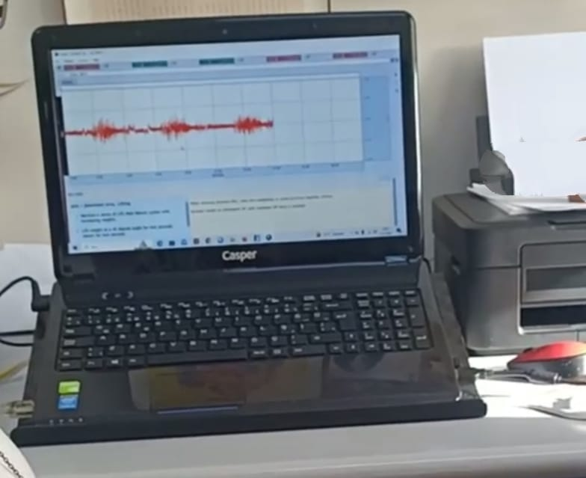
Figure 1. Experimental Set up

3.3 Sample Production
Production constants should be given. Dependent and independent parameters should be given. Table can be used here. Sample properties are given in Table 1.

Table 1. Sample properties
Sample Name | Parameter 1  [ml] | Parameter 2  [m] | Parameter 3  [ºC]
A | 2 | 1 | 30
B | 2 | 1 | 60
C | 2 | 2 | 30
D | 1 | 1 | 30

3.4 Characterization
Dependent parameters should be explained.

- RESULT AND DISCUSSION
4.1 Xxxxxxxx Results

Xxxxx results are given in Table 2.

Table 2. Xxxxx results
Sample Name | Xxxxxx  [MPa]
A | 5,90
B | 9,03
C | 7,05
D | 6,72

According to the results given in Table 2, ………eveulate the results here……….

4.2 Xxxxxxxx Results

Xxxxx results are given in Figure 2.

5. CONCLUSION
To summarize, embroidered textile-based electrodes ……………………………….

All of these electrodes were …………………………………………...

REFERENCES
-------------Use APA style--------------
- Stawiński, Wojciech, et al. "The influence of acid treatments over vermiculite based material as adsorbent for cationic textile dyestuffs." Chemosphere 153 (2016): 115-129.
- Ikhtiyarova, G., Valeeva, N., Aripdzhanova, M., Ayupova, M., & Usmanova, G. (2023). Development of a sorbent based on chitosan and vermiculite for purification of textile wastewater. In E3S Web of Conferences (Vol. 434, p. 02033). EDP Sciences.

